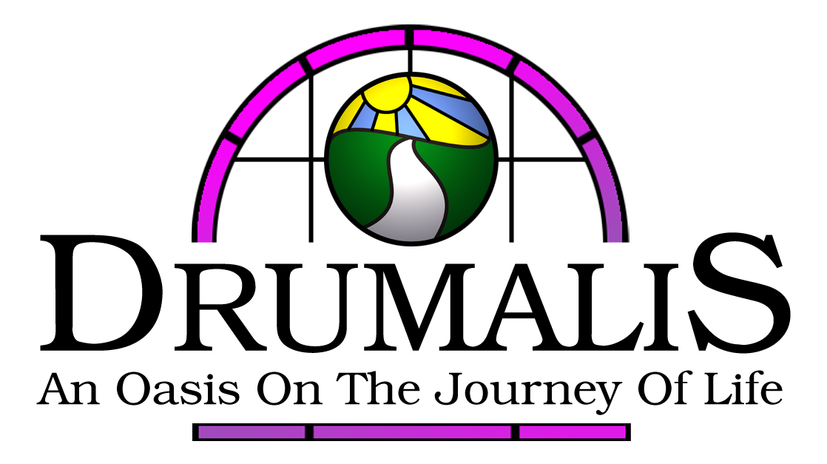

Glenarm Road Larne County Antrim BT40 1DT

Tel (028) 28272196/28276455 Fax (028) 28277999 Email drumalis@btconnect.com Website www.drumalis.co.uk
Pathways Registration Form
2023 – 2024
Please use block capitals to complete form

NAME: …………………………………………………………………………………….
ADDRESS: …………………………………………………………………………………….

TELEPHONE NO: …………………………………………………………………………………….

EMAIL: …………………………………………………………………………………….
(If you do not have a personal email address, we would be grateful if you would indicate one where we might leave messages)
PARISH: …………………………………………………………………………………….

- Why would you like to do this course?

- Is there any particular area of faith or ministry in which you are particularly interested?

- What previous experience have you had in pastoral ministry? (e.g. family caring, parish, hospital, school work, courses)

- What concerns, reservations or doubts do you have about the course?

……………………………………………………………………………………………………..
……………………………………………………………………………………………………..

It is possible to take part in the course either in-house or via Zoom.

Do you wish to access the course in-house or via Zoom?

Fees for the course, which are subsidized by the Friends of Drumalis and the All Hallows Trust,, are £225 per year for those who wish to take part in-house and £165 per year for those who wish to take part via Zoom.

To confirm your acceptance of a place on the course, please forward a deposit of £40 by September 23th.

Please indicate below your plans to make payment (tick as appropriate):

1. I intend to pay the fees in one instalment 

2. I intend to make an initial payment/deposit of £40 
and the balance in instalments by May 23,2024

